*Conditions :*

* If else :

it is used to return true in if block and false result will be shown in else block.you can independently use if but else is dependent on on if condition.

var age =19;

if (age>18){

console.log("eligible for cnic");

}else{

console.log("not eligible for cnic");

}

There are more types of if else statement conditions which are as follows:

* If else-if :

var per=prompt("What is your percentage ?");

var percentage=parseInt(per);

if(percentage>80){

    alert("your grade is A");

}

else if(percentage>70){

    alert("your grade is B");

}

else if(percentage>60){

    alert("your grade is C");

}

else {

    alert("you'r fail!");

}

* Nested-if :

var score=92;

if(score>80){

    alert("Grade A");

    if(score>90){

        alert("Got Trophy!");

    }

}

else{

   alert("fail");

}

* set of condtions with logical operators

var value1="u";

if(value1==="a" || value1==="i" || value1==="e" || value1==="o" || value1==="u"){

    alert("its a vowel");

}

else{

    alert("its not a vowel");

}

***Switch Case :***

const guess=Math.random();

let another=6*guess;

let breakk=Math.round(another);

//console.log(breakk);

switch(breakk){

    case 1 :

        console.log("guessed right won prize bond congo");

        break;

    case 6 :

        console.log("guessed right won prize bond congo");

        break;

    case 3 :

            console.log("guessed right won prize bond congo");

            break;

default:

    console.log("better luck next time!");

}

console.log(breakk);

We can mix switch case whereunder if else if present.

You cant do switch case comparisions , just do equality check.

Grouping case can happened by not including break after a case. 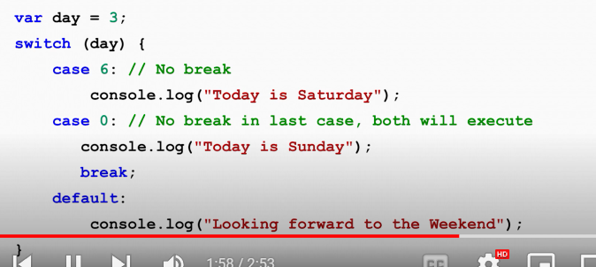Switch case in js check eqality with === called strict comparision.

